**Orchid Bouquet**

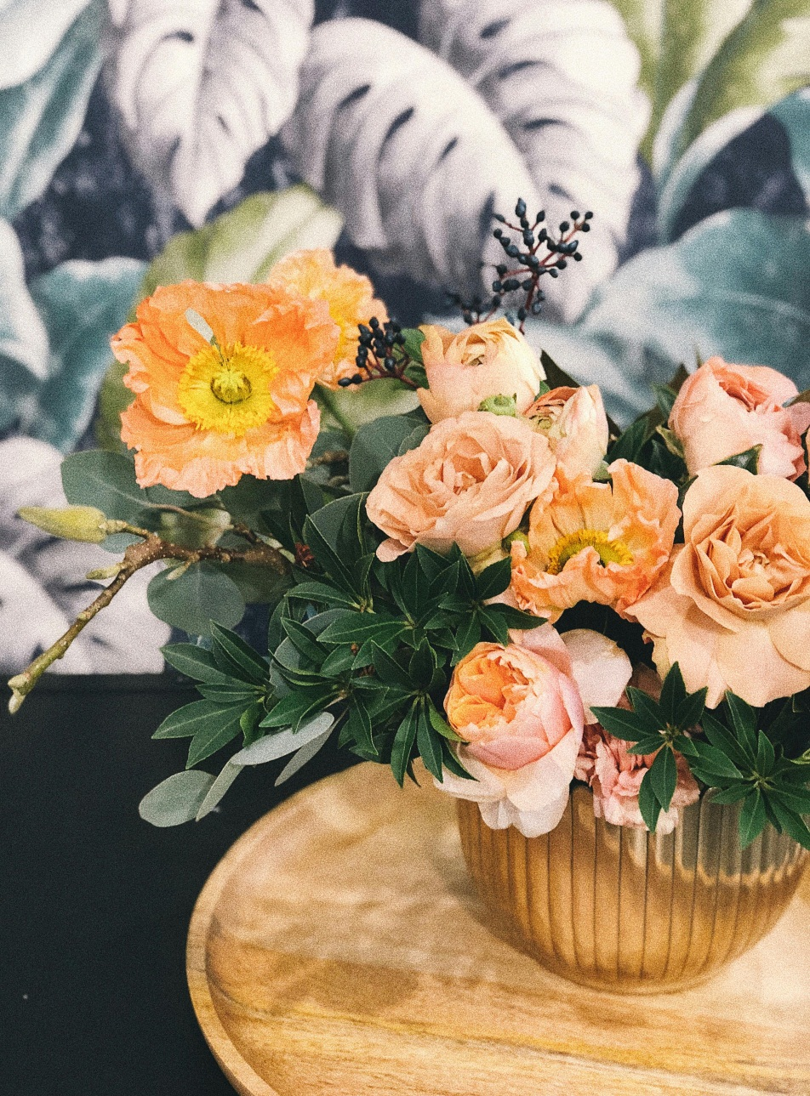

An orchid bouquet is a beautifully crafted arrangement of fresh orchid flowers, often featuring a variety of colors and species of orchids. These bouquets are designed to showcase the elegance and natural beauty of orchids, making them a popular choice for special occasions such as weddings, anniversaries, or simply as a thoughtful gift. With their delicate petals and graceful appearance, orchid bouquets add a touch of sophistication and charm to any setting, making them a timeless symbol of love, admiration, and appreciation.

**CATEGORIES:** Classic Orchid Bouquets,Exotic Orchid Arrangements,Monochromatic Orchid Bouquets,Mixed Orchid Bouquets.

**INFORMATION**: They are often given as a congratulations flower or to wish someone good luck. They also convey friendship, warmth, and well-wishes. Pink orchids are most often seen as symbols of femininity, grace and elegance.

**Price**: ~~$59.00~~ $49.00